Lab 2

Name: Utkarsh Pandey

1.  Calculate the multiplication and sum of two numbers.

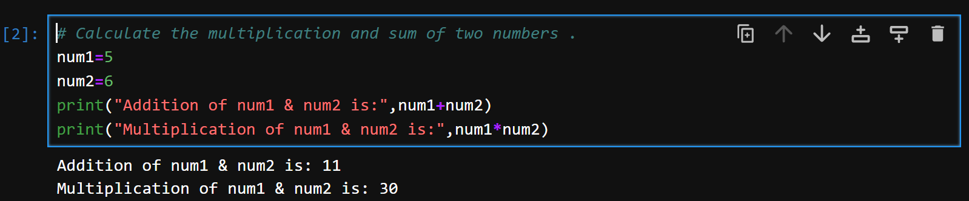

2. Declare two variables and print that which variable is largest using ternary operators.

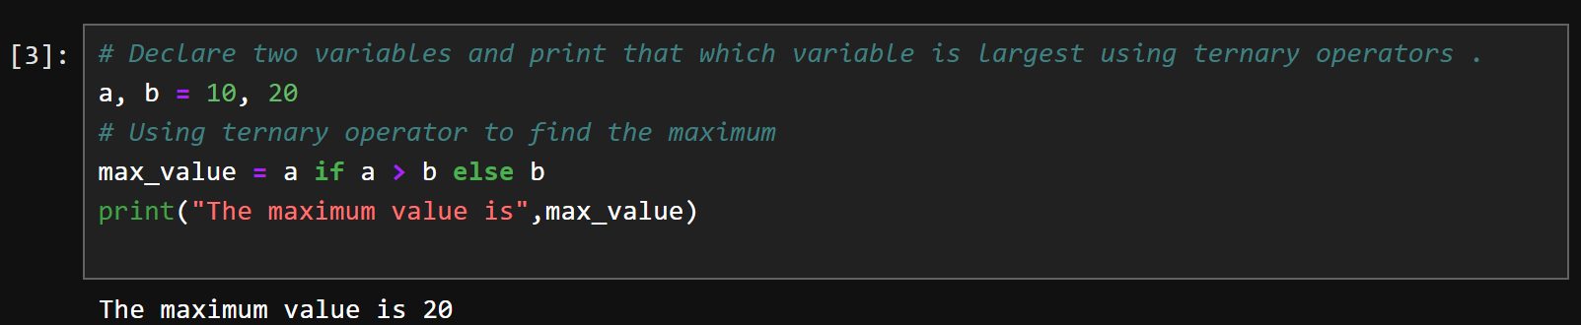

3. Python program to convert the temperature in degree centigrade to Fahrenheit.

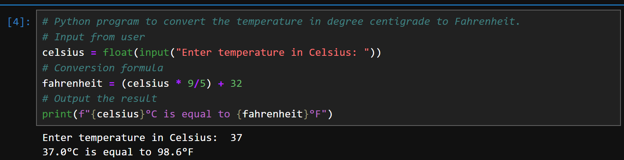

4. Python program to find the area of a triangle whose sides are given.

